Bahria University,

Karachi Campus



LAB EXPERIMENT NO.

___02___

LIST OF TASKS

|  |  |
| --- | --- |
| TASK NO | OBJECTIVE |
| **01** | Create 4 Components Each Component contains at least 5 Classes. |
| **02** | Add Attributes and Operations in Classes for Forward Engineering |
| **03** | Add more operations and Attributes via Coding in JAVA language for Alll Classes and Apply Reverse Engineering for changing Class Diagram |
|  |  |

Submitted On:

10-03-2023

(Date: DD/MM/YY)

**Task No. 1:** Create 4 Components Each Component contains at least 5 Classes

**Solution:**

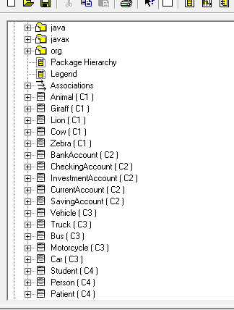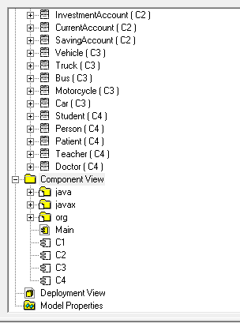

**Task No. 2:** Add Attributes and Operations in Classes for Forward Engineering

**Solution:**

**Component 1:**

//Source file: C:\shoaib\shoaib.java

private class BankAccount{

private String AccountName;

private int Balance;

public BankAccount(){}

public void Deposi(){}

public void withdraw(){}}

private class CheckingAccount{

private int LastCheckNum;

public BankAccount theBankAccount;

public CheckingAccount(){}}

private class InvestmentAccount{

private String AccountRep;

public BankAccount theBankAccount;

public InvestmentAccount(){}

public void Withdraw(){}}

private class CurrentAccount{

private int minimumBalance;

public BankAccount theBankAccount;

public CurrentAccount(){}}

private class SavingAccount{

private Float Interestrate;

public BankAccount theBankAccount;

public SavingAccount(){}}

**Component 2:**

//Source file: C:\shoaib\shoaib.java

private class BankAccount{

private String AccountName;

private int Balance;

public BankAccount(){}

public void Deposi(){}

public void withdraw(){}}

private class CheckingAccount{

private int LastCheckNum;

public BankAccount theBankAccount;

public CheckingAccount(){}}

private class InvestmentAccount{

private String AccountRep;

public BankAccount theBankAccount;

public InvestmentAccount(){}

public void Withdraw(){}}

private class CurrentAccount{

private int minimumBalance;

public BankAccount theBankAccount;

public CurrentAccount(){}}

private class SavingAccount{

private Float Interestrate;

public BankAccount theBankAccount;

public SavingAccount(){}}

**Component 3:**

//Source file: C:\shoaib \shoaib.java

private class Vehicle{

private String Model;

private String name;

private String Owner;

private String Make;

public Vehicle(){}

public int CalcMileage(){

return 0;}

public int CalcUsedPrice(){

return 0;}}

private class Truck{

private int maxSpeed;

private int PassengerCapacity; private int NoOfTyres;

public Vehicle theVehicle;

public Truck(){}

public void doorOpen(){}

public void doorClose(){}}

private class Bus{

private int PassengerCapacity; private String Ac;

public Vehicle theVehicle;

public Bus(){}

public void doorOpen(){}

public void doorClose(){}}

private class Motorcycle{

private String ignitionType; private int cc;

private int Price;

public Vehicle theVehicle;

public Motorcycle(){}}

private class Car{

private boolean AC; private String Automatic;

private int HorsePower; public Vehicle theVehicle;

public Car(){}

public void doorClose(){}

public void doorOpen(){}}

**Component 4:**

//Source file: C:\shoaib\shoaib.java

private class Student{

private int id;

private String major;

private int courses;

private String SchoolName;

public Person thePerson;

public Student(){}

public void RegisterCourses(){}

public void appearsInExams(){}}

private class Person{

private String Name;

private int age;

private String Nationality;

private String address;

private int Height;

private int weight;

public Person(){}

public void walk(){}

public void talk(){}

public void eat(){}

public void sleep(){}}

private class Patient{

private String disease;

private String previousRecord;

private String doctorName;

private String alergies;

public Person thePerson;

public Patient(){}

public void payBill(){}

public void beChecked(){}}

private class Teacher{

private String id;

private String FacultyType;

private int CourseTeaches;

private int Salary;

public Person thePerson;

public Teacher(){}

public void Make_Quiz(){}

public void TeachStudents(){}}

private class Doctor{

private int id;

private String Experience;

private String speicaity;

private String WorksAt;

public Person thePerson;

public Doctor(){}

public void OperatePatients(){}

public void prescribeMedicines(){}}

**Task No. 3:** Add more operations and Attributes via Coding in JAVA language for Alll Classes and Apply Reverse Engineering for changing Class Diagram

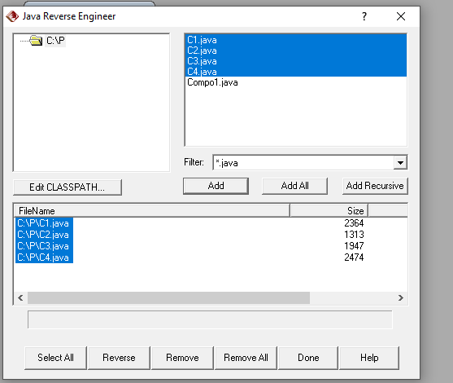**Solution:**

